Division Info Batch Feed Configuration Document

Database Changes

New table is added. Please find attached the XPEDX_LEGACY_UOM_XREF.xml
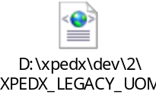

Table Name |  | XPEDX_LEGACY_UOM_XREF
Overview
Extensions/Custom/Hang-off |  | Custom
Primary Keys |  | XPEDX_LGCY_UOM_PK
Index on
Attribute Name | Column Name | Data Type/Size | OOB Data Type Name | Default Value | Description
UOM | UOM |  | UOM | ‘ ‘ | EDI UOM
LegacyUOM | LEGACY_UOM |  | Text-3 | ‘ ‘ | Legacy UOM
LegacyType | LEGACY_TYPE |  | Text-10 |  | Legacy Type
LegacyDesc | LEGACY_DESC |  | Description-40 |  | Legacy Description

Service Configuration Done
Go to Application Platform->Process Modeling->General->General->Services->Create new service (XpedxLegacyUOM)

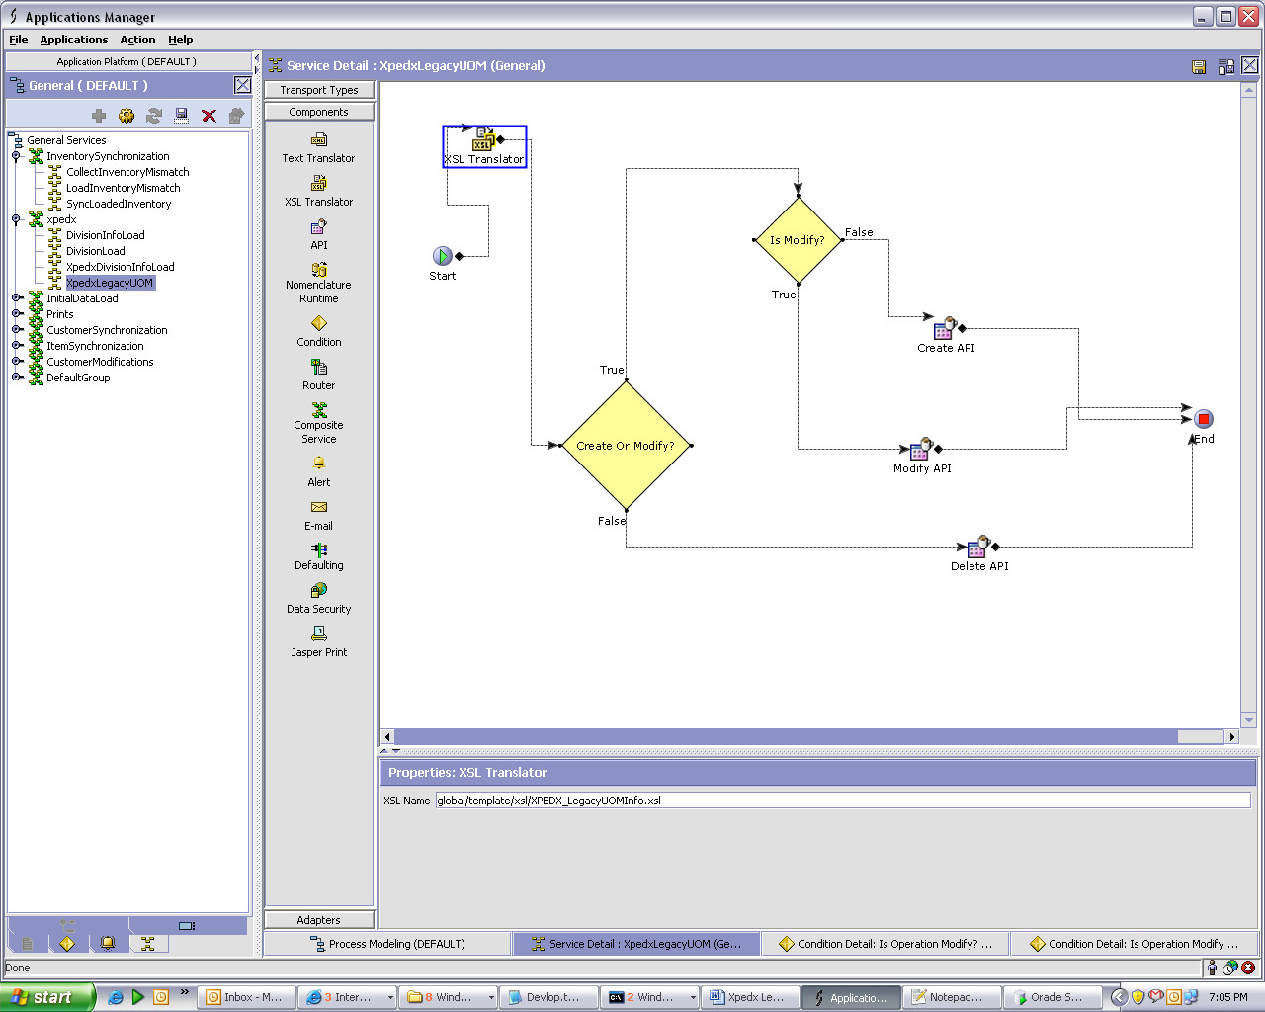

XSL Name=global/template/xsl/XPEDX_LegacyUOMInfo.xsl

Find attached the XSL used it has to be saved in “<INSTALL-DIR>\extensions\global\template\xsl “folder.
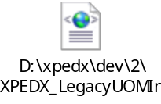

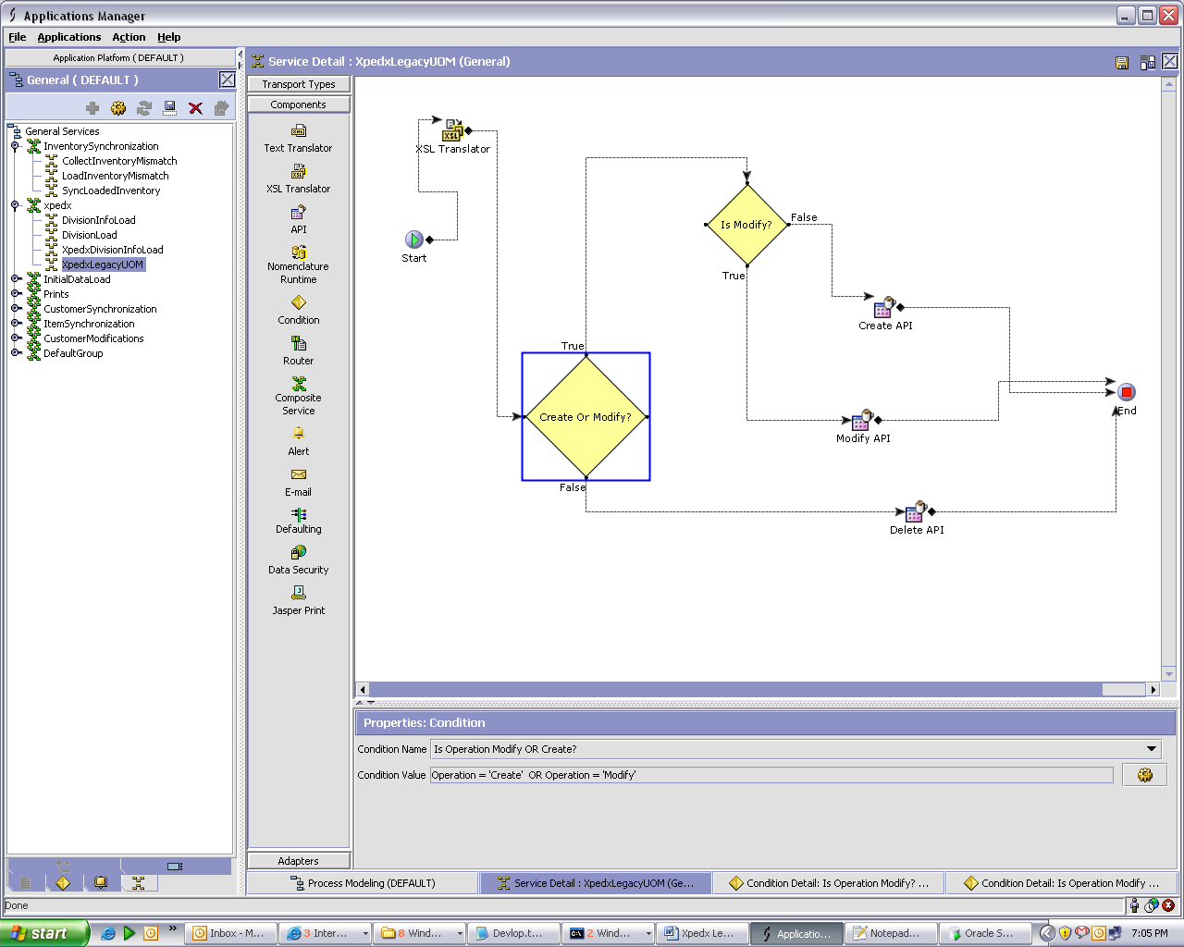

Condition Name = Is Operation Modify OR Create?
Condition Value = Operation Is 'Create' OR Operation Is 'Modify'

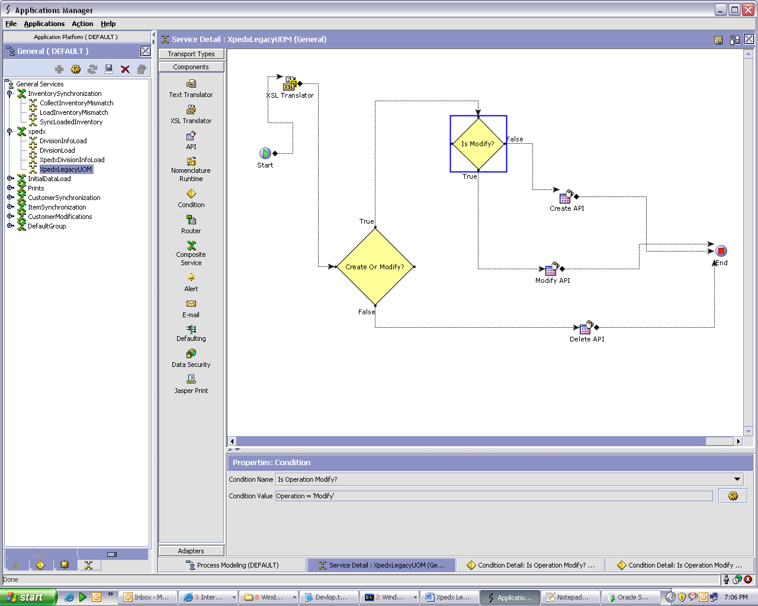

Condition Name = Is Operation Modify?
Condition Value = Operation Is 'Modify'

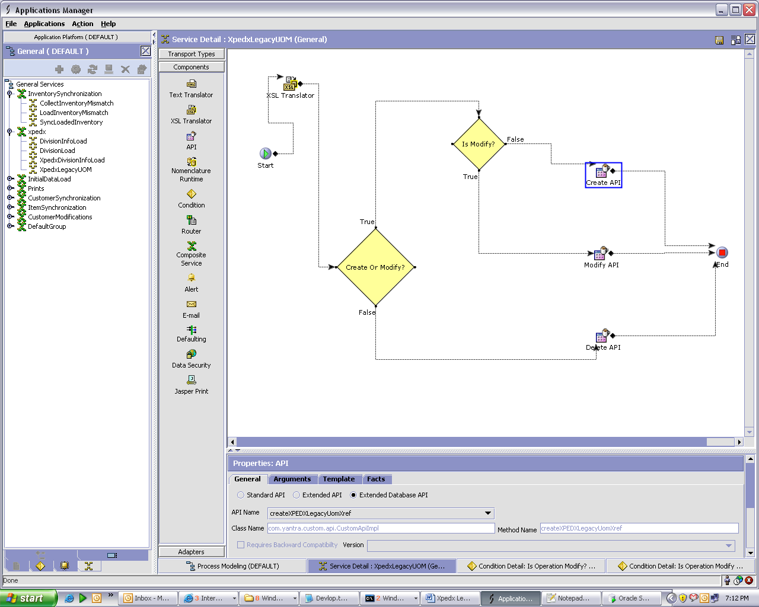

Extended Database API
API Name :- createXPEDXLegacyUomXref
Class Name:- com.yantra.custom.api.CustomApiImpl
Method Name:- createXPEDXLegacyUomXref

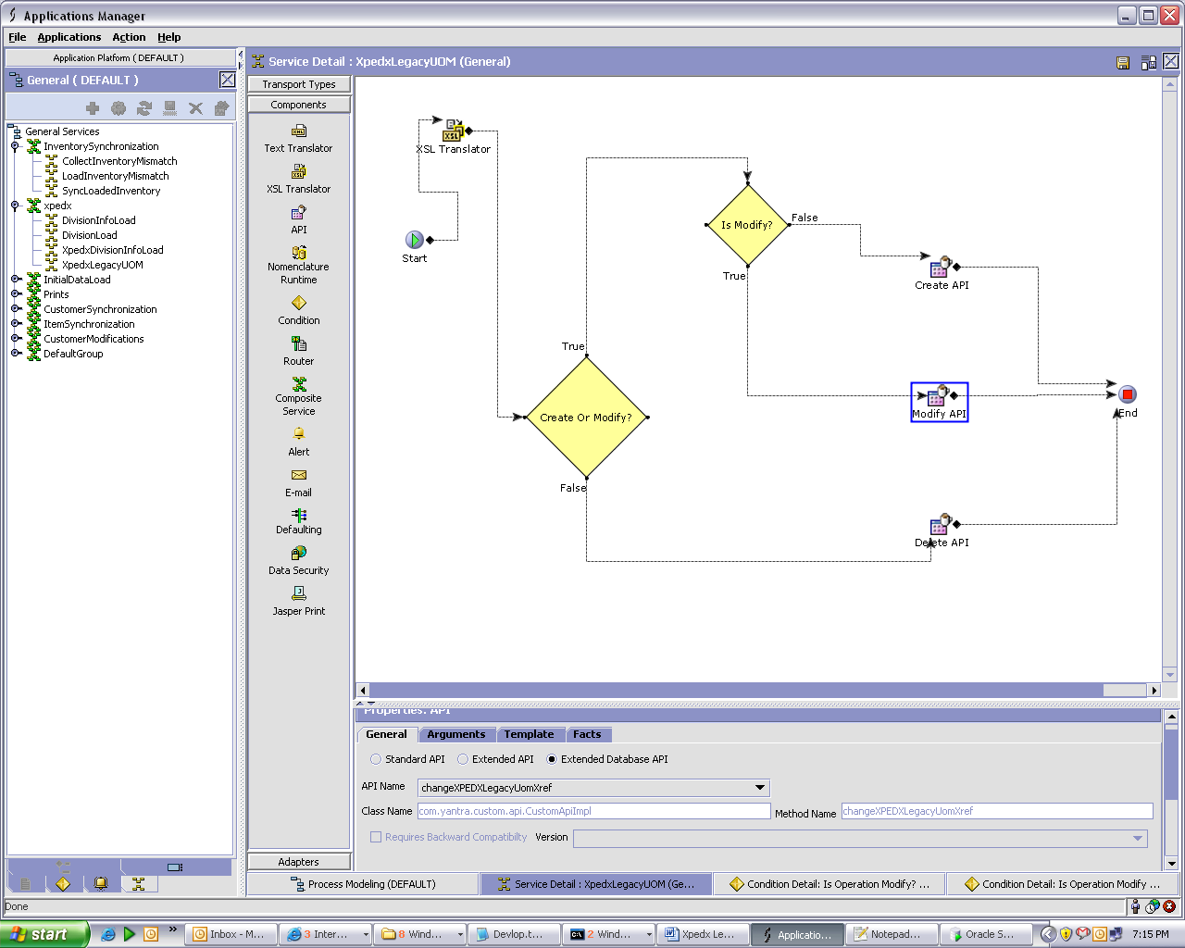

Extended Database API
API Name :- changeXPEDXLegacyUomXref
Class Name:- com.yantra.custom.api.CustomApiImpl
Method Name:- changeXPEDXLegacyUomXref

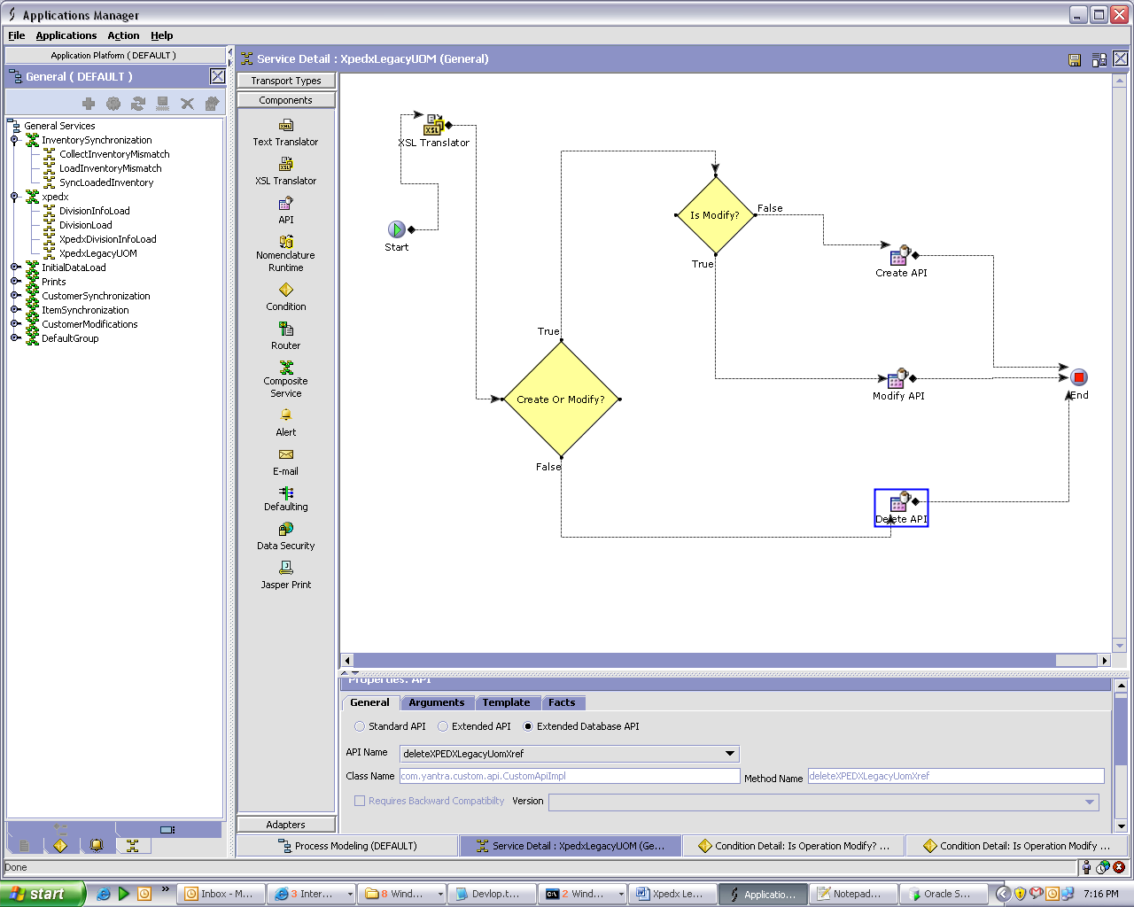

Extended Database API
API Name :- deleteXPEDXLegacyUomXref
Class Name:- com.yantra.custom.api.CustomApiImpl
Method Name:- deleteXPEDXLegacyUomXref

Input Received from Web Method.

<?xml version="1.0" encoding="utf-8"?>
<LegacyUOMs>
<LegacyUOM ProcessCode="M" EnvironmentId ="Kbc" CompanyCode ="ram" EDIUom="KM" LegacyUom="Kil" UOMDescription="Kilometer to Mile" />
</LegacyUOMs >

Format of InputXML for Database API to Insert/Change/Delete records to is.

<?xml version="1.0" encoding="UTF-8"?>
<XPEDXLegacyUomXref Createprogid=" " Createts=" " Createuserid=" "
LegacyDesc=" " LegacyType=" " LegacyUOM=" " Lockid=" "
Modifyprogid=" " Modifyts=" " Modifyuserid=" " UOM=" "/>

Field Mapping

No. | Field Name | Length | Data Type | Description
1. | Environment Id | 2 | String | This field is used for capturing the environment we are talking to. For e.g PROD, STAGING, DEV. This is populated from the customer batch.
2. | Company | 2 | String | The field is used by webMethods as a queue identifier.
3. | Process Code |  | String | A = Add/C = Change /D = delete.  Sterling recommends we get a delta load and not full refresh. Sterling will ignore the process code in case this is a full refresh.
4. | EDI UOM | 2 | String | Unit Of Measure for the EDI Transactions. For e.g SH (SHEET), CT(CARTON), BA(BAG), BL(BALE)
5. | Legacy UOM | 3 | String | Unit Of Measure for the Legacy systems. For e.g SHT (SHEET), CTN(CARTON), BAG(BAG), BAL(BALE)
6. | Legacy UOM Description |  | String | Description for the Legacy Unit of Measure. For e.g, CARTON, SHEET, BAG etc.

Unit Test Scenarios

Test No. | Test Description | Execution Instructions | Expected Result
1 | Pass the Legacy UOM input as mentioned in the input document above. Test with ProcessCode as A. |  | The records should be created in XPEDX_LEGACY_UOM_XREF.
2 | Test With ProcessCode as D. |  | The records should be deleted from XPEDX_LEGACY_UOM_XREF.
3 | Test with ProcessCode as C. |  | The records should be modifed from XPEDX_LEGACY_UOM_XREF.

Appendix : Xpedx Batch Feeds-Legacy UOM Detailed Design V1.1

